# Module Two Class Assignment

Mayel Espino

Department of Data Science University of San Diego

ADS-500B-01-SP21 - Data Science Programming

M.S. Jules Malin

March 11, 2021

# Module Two Class Assignment

# Exercises

## Exercise One

Dataset (located in your assignment prompt in Blackboard) contains apportion of the data from NYC about causes of death for the year 2010.

Dataset format: CSV

Field names (in order): Year, Ethnicity, Sex, Cause of Death, Death Count.

Answer the following questions from this data using UNIX commands.

1.1: How many male record groups and how many female record groups does the data have?

1.2: How many white female groups are there? Copy entire records of females to a new text file where the records are organized by death count in descending order.

1.3: List all causes of death by their frequencies in descending order. What are the three most frequent causes of death for black males, and five least frequent causes of death for Hispanic females?

### Answer 1.1

If grouped by Ethnicity there are 6 Male groups, and their counts are the second column

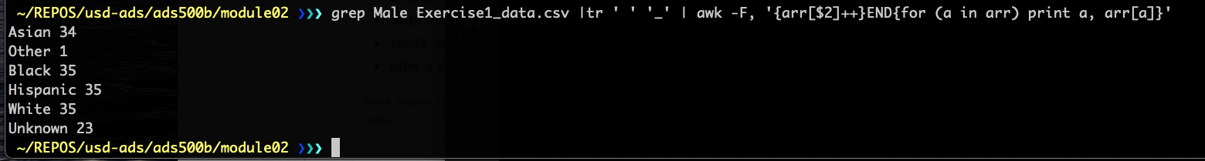

If grouped by cause of death there are 35 Male groups, and their counts are the second column:

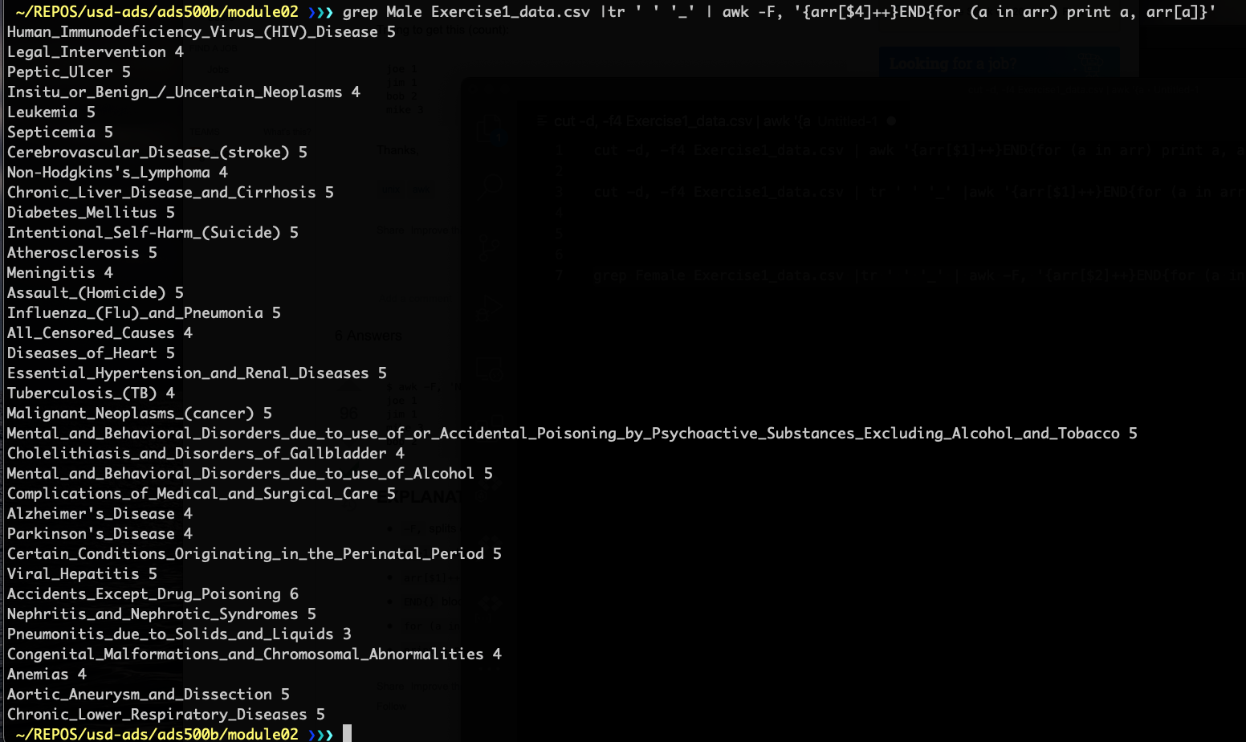

If grouped by ethnicity, there are 6 Female groups, and their counts are the second column:

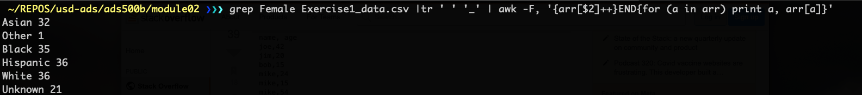

If grouped by cause of death there are 36 Female groups, and their counts are the second column:

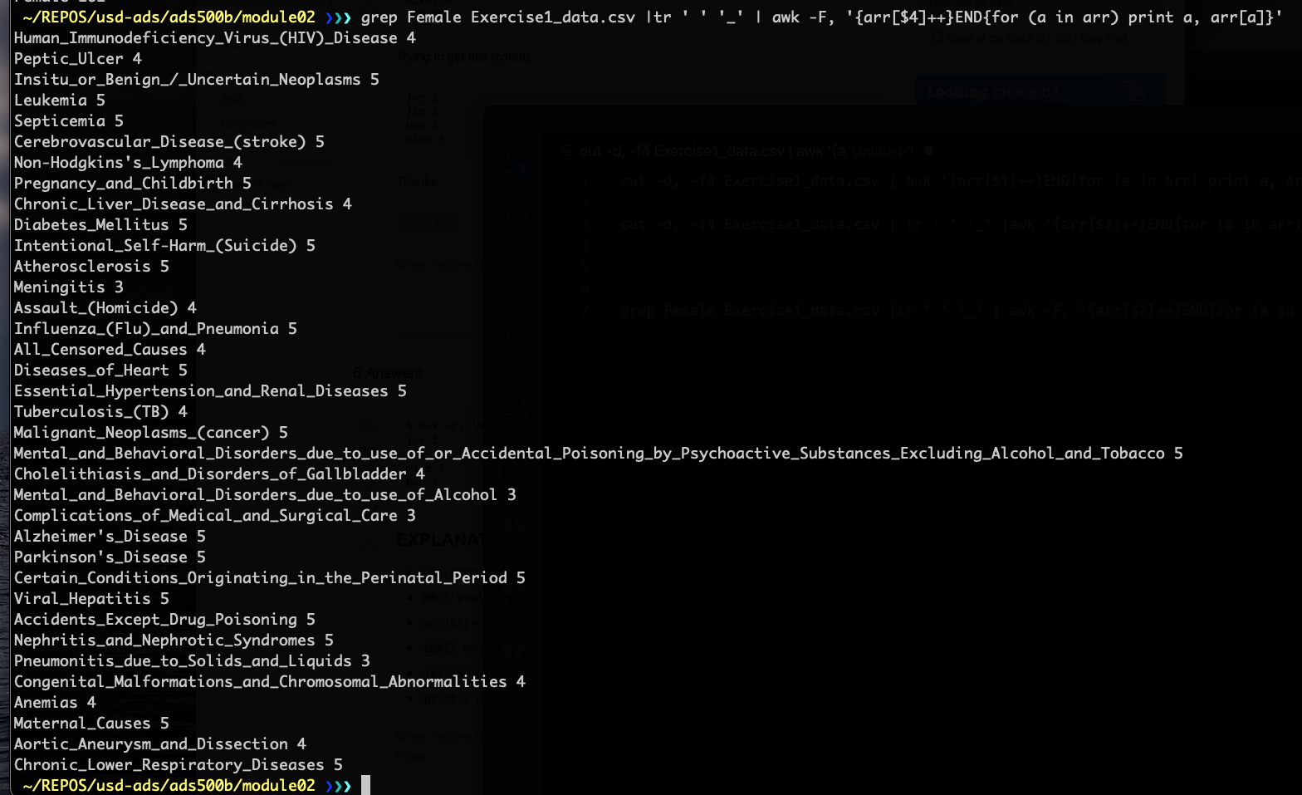

### Answer 1.2

There are 36 groups, when grouped by cause of death, for white Females:



They are:

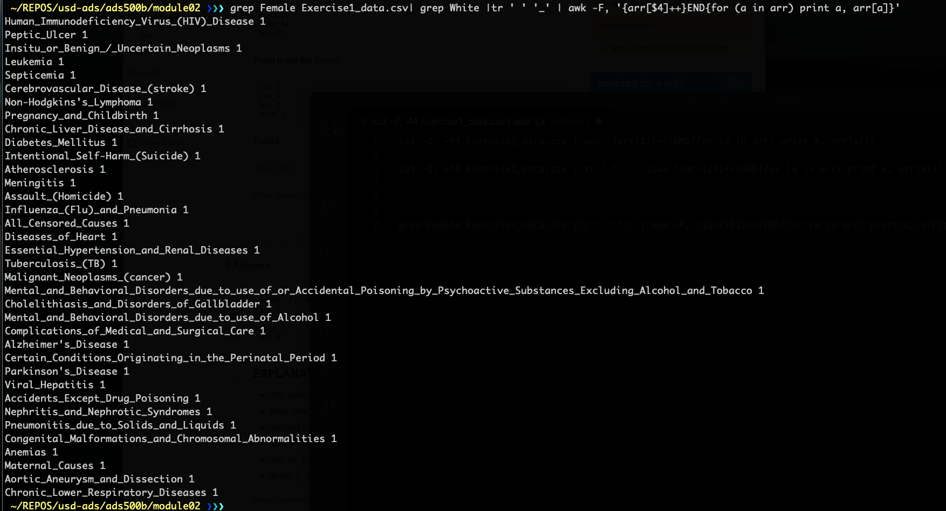

Copy entire records for white females to a text file, organized by death count:

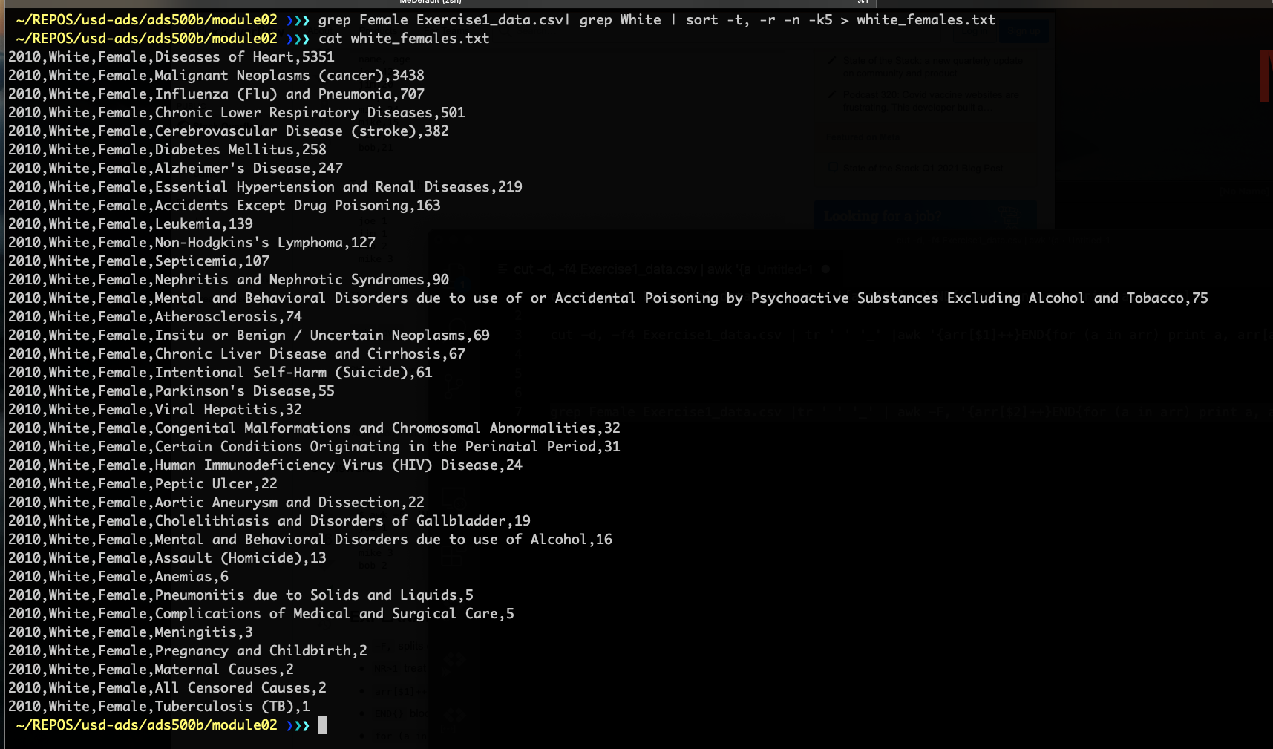

### Answer 1.3

List of all the causes of death in descending order of frequency

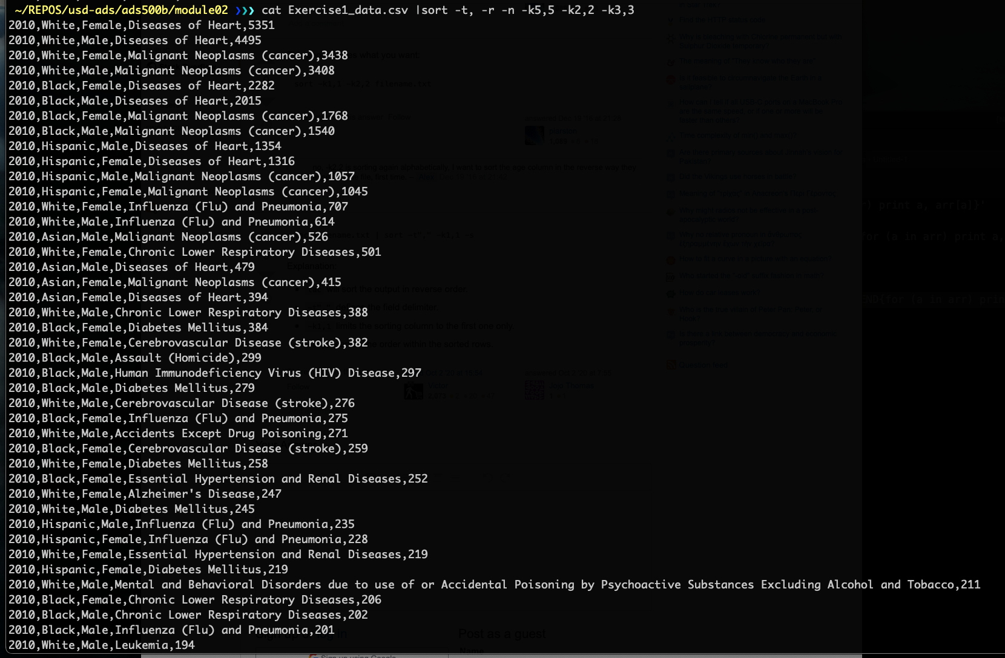

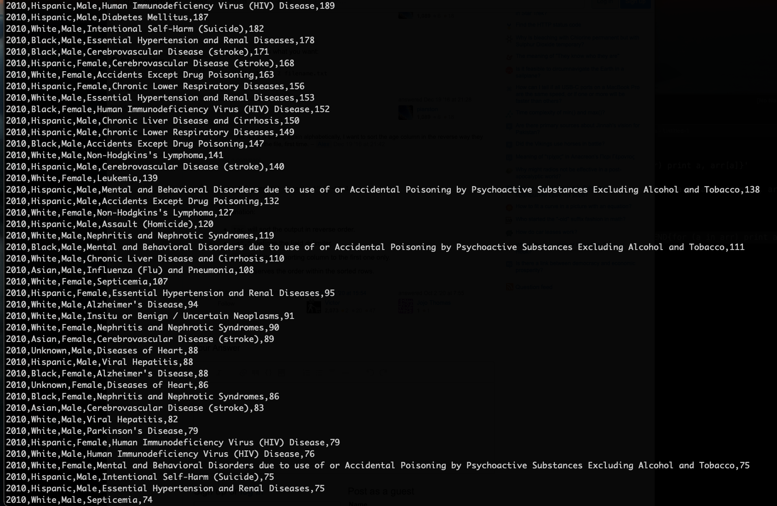

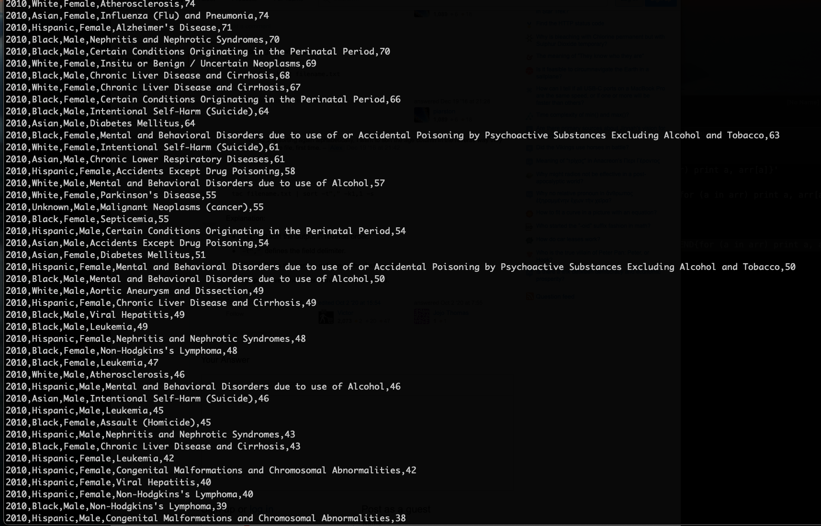

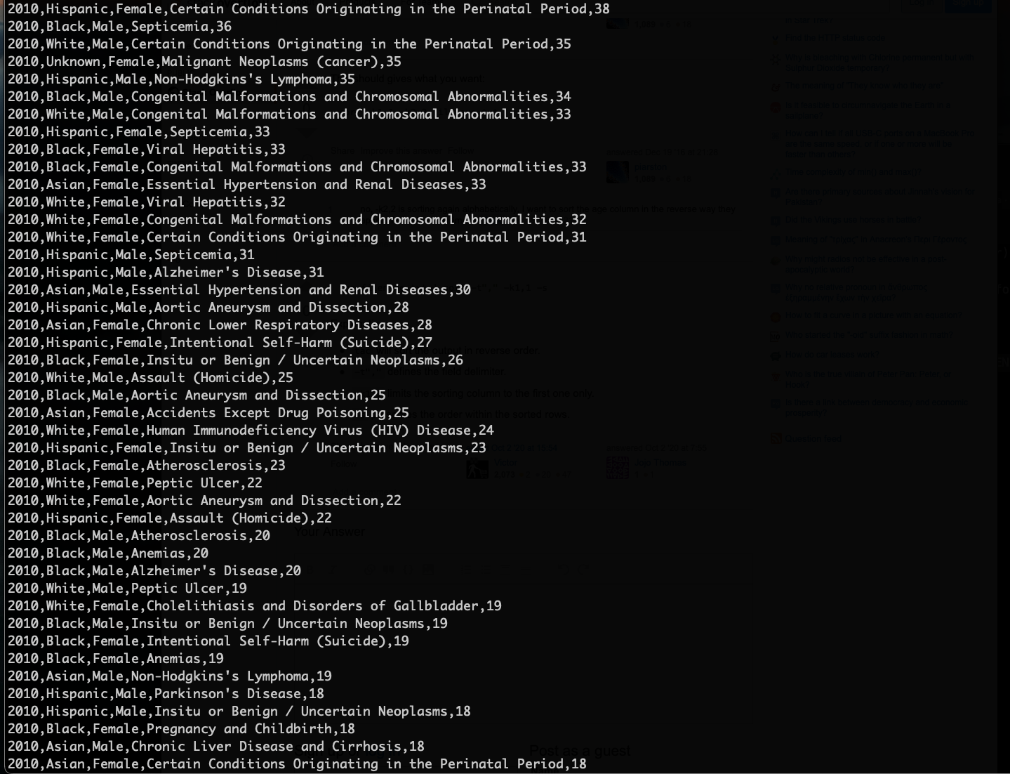

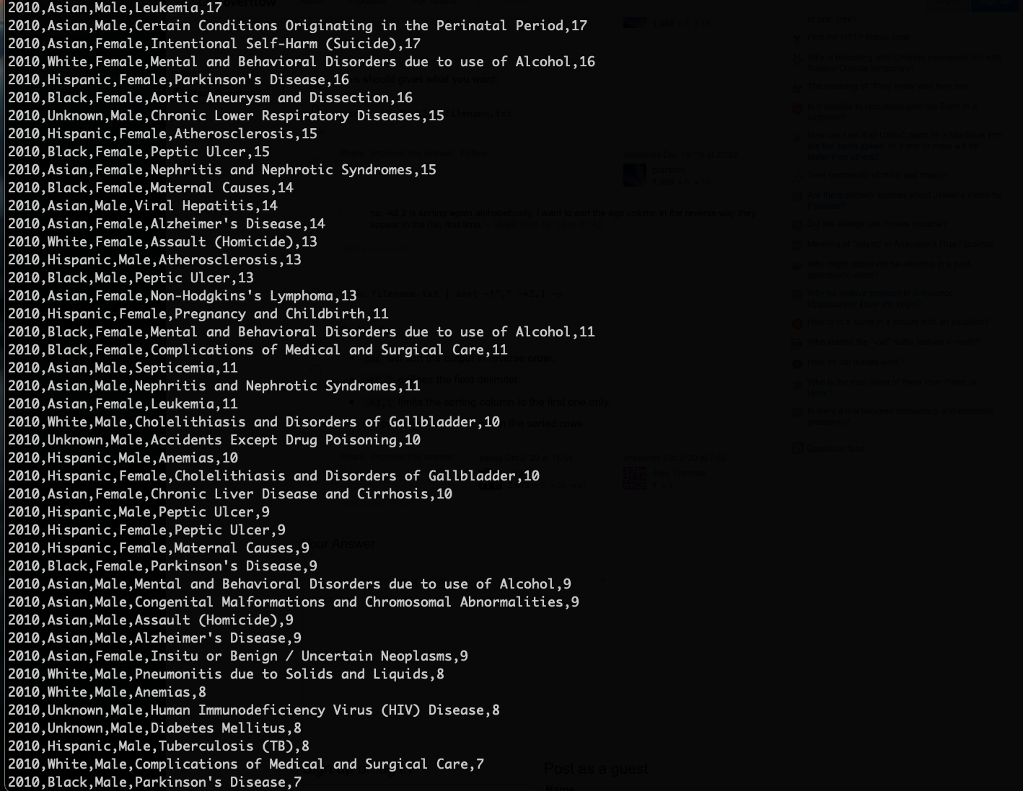

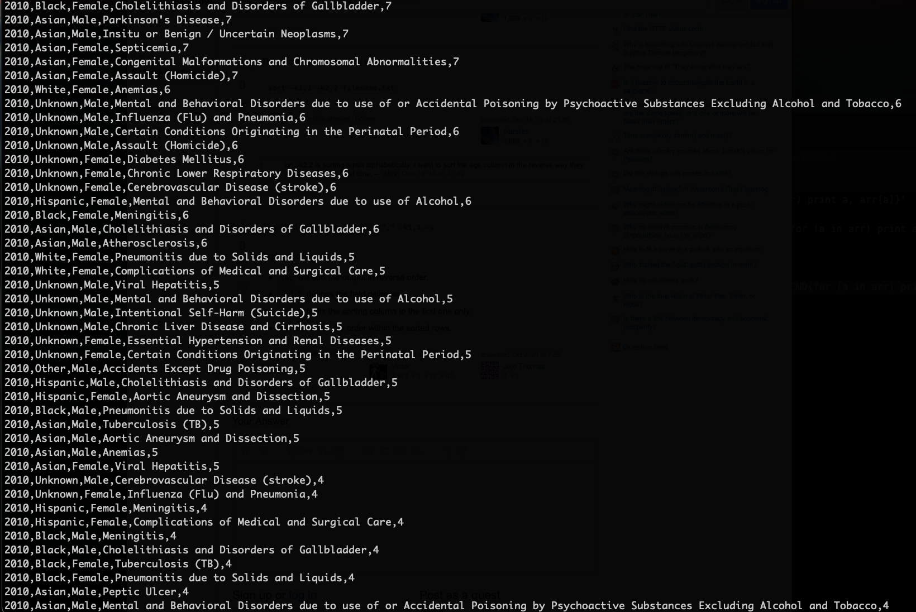

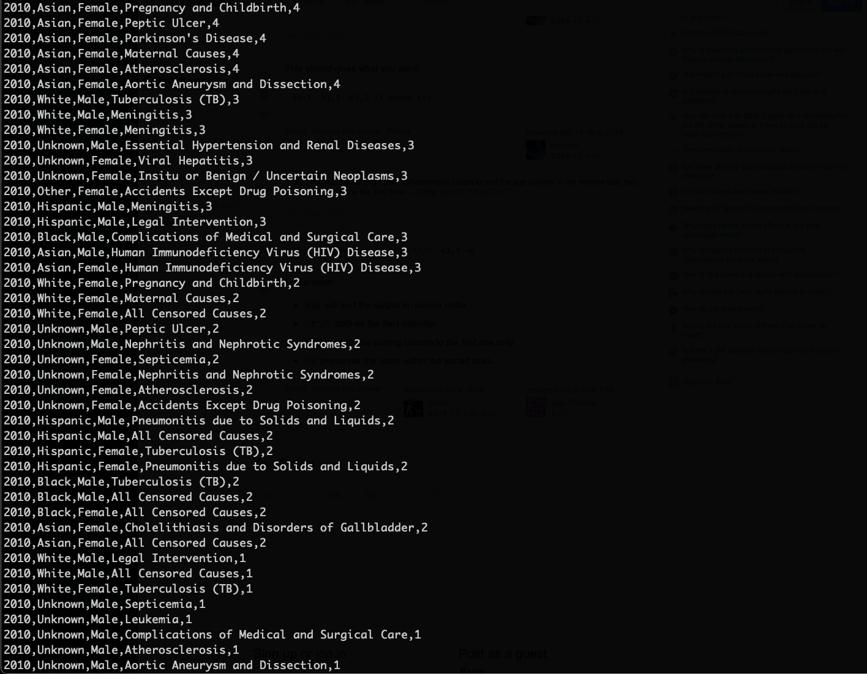

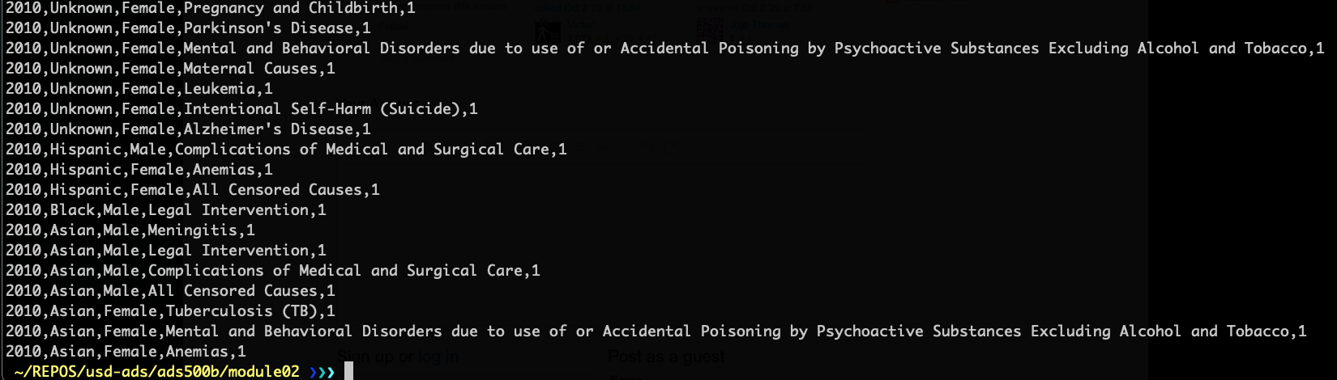

The top three causes of death for Black Males:



The bottom five causes of death for Hispanic Females

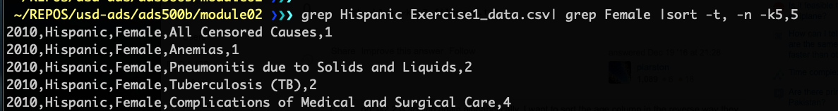

## Exercise Two

Obtained from UNICEF, the Exercise 2 Dataset (located in your assignment prompt inBlackboard) contains data related to the population of 70+ countries for the year 2017.Dataset format: CSV

Field names (in order): Country, Population, Urban Population, Percentage of Urban Population. Answer the following questions from this data using UNIX commands:

2.1: Which country has the lowest percentage of urban population?

2.2: List the countries where the urban population is more than 10 million and yet they comprise less than half of the population.

### Answer 2.1



### Answer 2.2

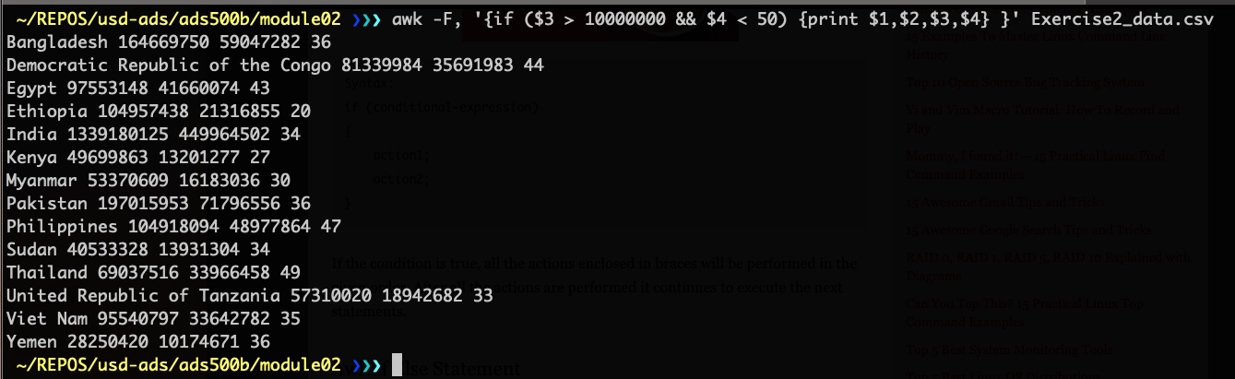

## Exercise Three

For the following exercise, use the Exercise 3 Dataset (located in your assignment prompt in Blackboard), which contains availability of essential medicines in 38 countries for the years 2007 - 2013, obtained from the World Health Organization (WHO).

Dataset format: CSV

Field names (in order): Country, Median availability of selected generic medicines (%) - Private, Median availability of selected generic medicines (%) - Public

3.1: Which country had the lowest percentage median availability of selected generic medicines in private.

3.2: List the top five countries with the highest percentage of public and private median availability of selected medicines in 2007–2013.

3.3: List the top three countries where it is best to rely on the private availability of selected generic medicines than public. Explain your answer with valid reasons.

### Answer 3.1



### Answer 3.2



### Answer 3.3



Reasons for selecting this answer:

1. The gap between the availability in the private and public sectors is 54.0 percent and up to 76.7 percent.
2. Typically, the private sector offers better service.

## Exercise Four

Write a Python script that assigns the list [25,18,9,13,34,15,22,17,12,37,15] to a variable “age” and uses that information to:

4.1: Determine if a person is in high school or not. Assume that for a person to be in high school, their age should be between 14 and 18, inclusive.

4.2: From the list, calculate the percentage of people not going to high school.

### Answers 4.1

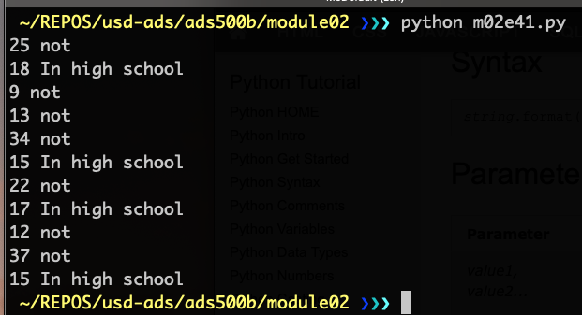

For the code, please see Figure 1 in the appendix.

### Answer 4.2

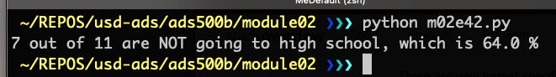

For the code, please see Figure 2 in the appendix.

# Appendix

**Figure 1**

Code for Answer 4.1

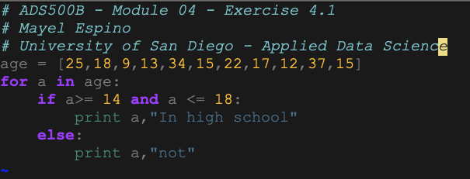

**Figure 2**

Code for Answer 4.2

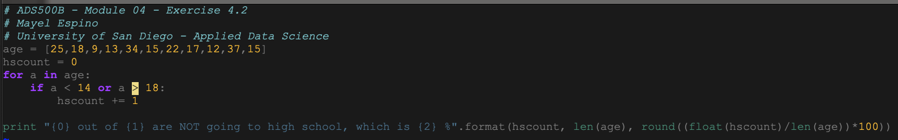

# References